

DRAFT
LAXFIELD ANNUAL PARISH MEETING

Monday 18 May 2026 at 7:00 pm in Laxfield Baptist Church

MINUTES

28 members of the public were present including Parish Council Chair, Rob Sutton, who chaired the proceedings.

The minutes from the 2025 Annual Parish Meeting were agreed as accurate.

As in previous years, an annual parish meeting (APM) booklet had been delivered to households, containing year-end reports from organisations and groups across the village. This booklet is also available on the Parish Council website, www.laxfield-pc.gov.uk.

Cllrs Anders Linder (Mid Suffolk District Council) and Henry Lloyd (Suffolk County Council) did not attend the meeting, due to the recent election. However, both councillors provided annual reports in the APM booklet and Parish Council website.

Reports from the chair of the parish council, Rob Sutton and the parish clerk, Peter Lowe were summarised at the meeting. The following points were highlighted in a presentation:
- Laxfield Parish Council operational costs are much higher than the annual Parish Precept and these have increased significantly over past 4 years, due to inflation and the rising costs of services and utilities. Each year fixed costs for the Parish Council take up 80% of the annual precept and the Parish Council relies on securing additional incomes, such as grants, fees and collection schemes to bridge the gap on paying for village maintenance, cemeteries and playing fields maintenance, as well as contributions to local community groups and charities.
- In 2025/26, the Finance Committee carried out a fundamental review of finances and the Parish Council agreed to curb costs wherever possible, to ensure we build up reserves to around £18,000 over the next couple of years.
- A snapshot of Community Infrastructure Levy (CIL) projects delivered in 2025/26 and those planned for the coming year, were discussed. CIL funds are now at £87,822 and there are no major developments in the pipeline to provide large levy windfalls. It is therefore crucial, given the work required to deliver on Laxfield’s ambitious Neighbourhood Plan, that the Parish Council utilises remaining funds effectively, as match funding to lever in external grants.
- This year, the Parish Council carried out significant work on the PIIP (Parish Infrastructure Improvement Plan), with a prioritisation exercise highlighting 5 key projects for delivery. New plans have been developed and allocated to a sub-committee or working group, to lead on external grant applications and delivery momentum.
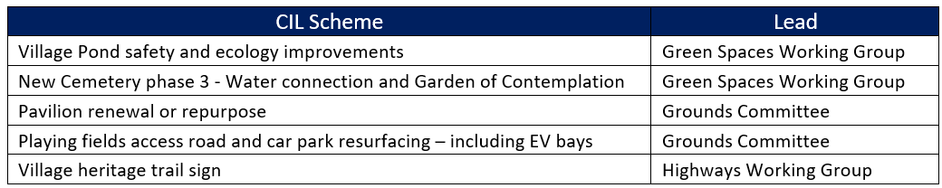

Questions from the floor were requested and the following points were raised and discussed:

A number of questions were raised in regard to the £5,000 increase in the precept, which then led to further questions about the state of the Parish Council's finances reducing over the past 4 years. Discussions took place in relation to operational and CIL income and expenditure, as well as the inadequate general reserves. Section 137 expenditure and the high cost of cemeteries maintenance, compared to other parish councils, was also raised. The member of the public was satisfied with the detailed explanations delivered in the clerk’s presentation. However, the chair and clerk agreed to provide a formal response on all the points raised.

A question was also raised about whether councillors and the clerk had training from SALC? The clerk and chair both confirmed that they have received SALC training and that they continue to look for, and take advantage of, any additional training opportunities.

A member of the public asked about the annual loan payment of £11,289, paid by the Parish Council. This is a Public Works Board Loan, originally taken out in 2009 for upgrading and refurbishing the Laxfield Village Hall. Over 17 years of a 25 year loan has now been paid. The loan takes up 20% of the annual precept and efforts were made to consolidate the loan in 2025/26. However, this was no longer financially viable, given that it’s near the end of the term.

Michael Knights (Fressingfield Scout Group), thanked the public and parish council for their support over the past 12 months and announced that their solar panels project was now complete.

Carlton Sands thanked Laxfield for raising nearly £2,993 for the poppy appeal and it was hoped this would exceed £3,000 soon.

The Parish Council thanked local volunteers for delivering another hugely successful Seniors Christmas Lunch. The clerk asked that residents come forward with projects or ideas on how the ‘Snook Bequest’ funds might be used to support the older members of our community in 2026/27.

The Chair highlighted the introduction of Laxfield’s new 482 bus service, which started in April 2026 and runs 4 times a day, 6 days a week. Residents are encouraged to use the services as much as possible to ensure it remains financially viable.

Meeting ended 7:38 pm

