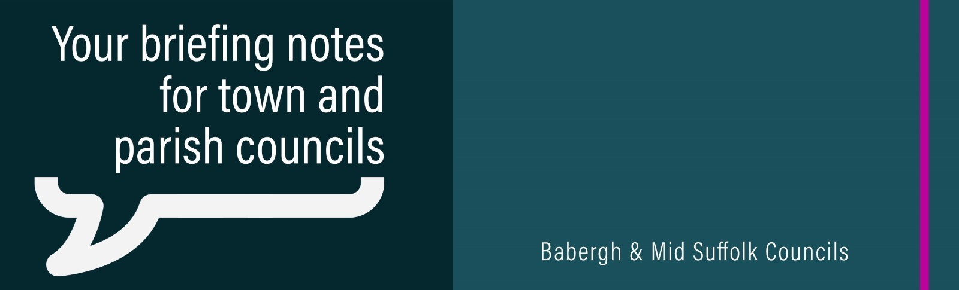
Government confirms ambitious new future for local government in Suffolk
The Secretary of State for Housing, Communities and Local Government has confirmed that three unitary councils will be created in Suffolk replacing the current system made up of Suffolk County Council and the five district and borough councils: Babergh, East Suffolk, Ipswich, Mid Suffolk and West Suffolk.

‘Shape the future of your community’ – Councils step in to provide funding for Neighbourhood Plans
Communities are being encouraged to shape the future of their area by creating a Neighbourhood Plan – after Babergh and Mid Suffolk District Councils stepped in with funding to support them.

Emergency support call for households hit by soaring heating oil costs
Thousands of households facing soaring heating oil costs need urgent government support, community leaders in Babergh and Mid Suffolk have warned.

New fund encourages Mid Suffolk communities to ‘think big’ on nature and water projects
A £525,000 fund has been established to support ambitious nature recovery and water management projects across Mid Suffolk.

Works starting on eagerly awaited 3G football pitch
Works to deliver a brand new 3G football pitch and mini athletics track in Stowmarket are due to start in the coming weeks.

Needham Market regeneration to continue following sale of former council offices
Mid Suffolk District Council has announced the sale of the remainder of its former office site in Needham Market to Hatch Homes – in a deal that supports the town’s regeneration and realises funds for reinvestment into council housing.

Council buys riverside haven to protect it for future generations
Mid Suffolk District Council has purchased almost eight acres of land in the heart of Stowmarket to preserve it as a future riverside haven for nature and wildlife for future generations.

From disused care home site to affordable housing
Work is underway to transform the disused site of a former care home in Eye into affordable housing – with 16 new homes set to be delivered for the local community.

Groundbreaking Commemorates the Start of Works to Expand High School
A groundbreaking event took place at Stowmarket High School, where the project team, local councillors, and school representatives gathered to celebrate the formal start of the school’s significant expansion programme.

Kick off for sports projects thanks to £400k investment
Sports clubs in Mid Suffolk are feeling the benefits of a unique fund which has already seen more than £400,000 awarded to level up sporting provision across the district.

£120k boost for art and culture in Mid Suffolk
From youth art festivals and dementia dance sessions to orchestra projects and drama workshops, art and culture projects in Mid Suffolk are receiving another funding boost thanks to grants from Mid Suffolk District Council.

Funding boost turns local projects into child’s play
Mid Suffolk District Council is investing in facilities for youngsters across the district, with two play areas and a scout hut securing funding in the latest round of Community Infrastructure Levy (CIL) awards.

