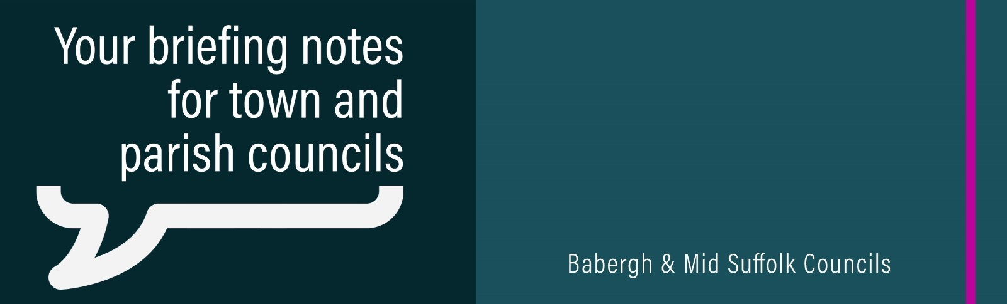
Councils call for urgent reform of sewage sludge regulations
Babergh and Mid Suffolk District Councils are calling for urgent action by the Government to tighten regulations governing the spreading of sewage sludge on agricultural land, citing serious concerns for public health, farming and the environment.

‘We back the bid’ – Councils support Ipswich ambition to be City of Culture
Babergh and Mid Suffolk District Councils are backing Ipswich’s bid to become City of Culture 2029 – saying it deserves Suffolk-wide support.

Boosting biodiversity by funding nature in your neighbourhood
Local groups are being urged to apply for new funding from Mid Suffolk District Council, designed to connect people with nature and restore natural habitats within communities.

Inspiring the next generation to explore their future in creative careers
Babergh and Mid Suffolk District Councils, in collaboration with East Suffolk District Council and MENTA, have launched a brand-new initiative designed to ignite curiosity, confidence, and ambition in young people.

Helping households to save money, eat well and reduce food waste
Households across Suffolk can now get free access to Five Dinners – an award-winning meal planner which helps them eat healthily, save money and reduce food waste.

Find out how much heat your home is losing – by borrowing a thermal camera for free
Suffolk residents can now borrow a thermal camera from their local library for free to detect where heat is escaping their homes and take action to stop the leaks.

